**Kofax Insight - DB Connection Maintenance**

Portal Knowledgebase 13453

**Summary**

**Applies to**:  Insight 5.0, 5.1, 5.2, 5.3  
**Date**:  April 12, 2016

**Summary**:  This article will describe where the main database (DB) connections for Insight can be accessed and maintained.

**Introduction**

During the normal course of business it may at some point become necessary to change the names, locations, and/or credentials used for connecting to the main DB’s that Insight uses.  As a general rule of thumb, anytime you change the details of a DB connection, you will need to update those connection details anywhere you have saved them in your application(s).

One common scenario where this can come about is if these DB’s are moved/migrated to some new infrastructure as part of a hardware and/or DBMS software upgrade.

Since these DB connections are often not touched since initial installation or prior upgrade, it may be hard to recall where these key DB connections are maintained.

NOTE:  Please note that this KB Article does not relate to new or empty DB’s, as could be encountered during some installation or Project creation scenario.  Please refer to your standard Insight documentation for details on creating and/or initializing empty DB’s.  This KB Article only relates to non-empty databases for existing Insight environments and Projects.

**Maintaining DB Connections for Insight**

Insight is comprised of one main DB for a given environment, *Admin*, and then two or three DB’s for each Project in that environment: *Meta*, *Data*, and optional *Staging* (your actual DB names may be different).  The connection details for these DB’s are maintained in the following places, and in the following recommended order for changing:

**Insight Installation Manager** - standalone exe tool  
    *Admin*

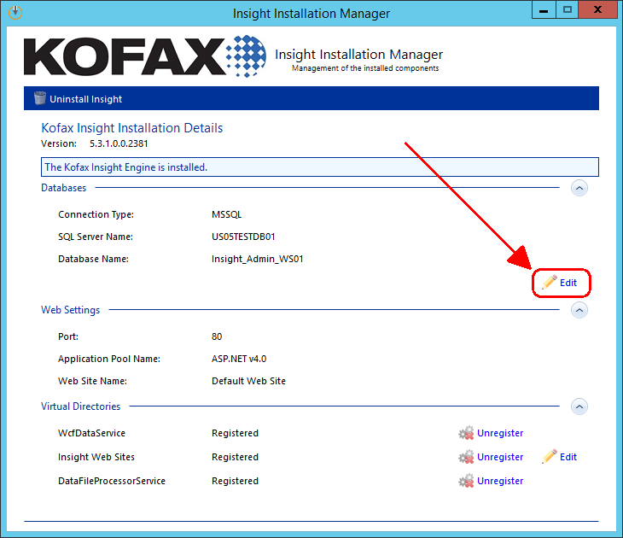

After clicking “Edit” you will get the following screen where you can modify the connection settings for *Admin* DB.

Be sure that “Use Existing Database” option is selected; otherwise your DB will be re-initialized (deleted and re-created).  
  
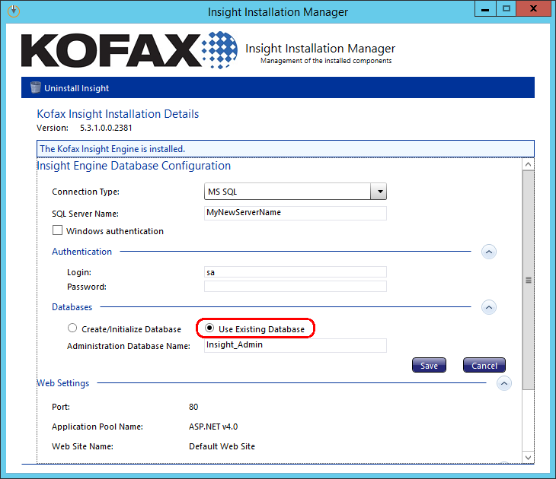  
  
**Insight Admin / Admin Console** - web app  
    *Meta*  
    *Data*  
    *Staging*

Select the desired Project from the Projects list and click “Change”:  
  
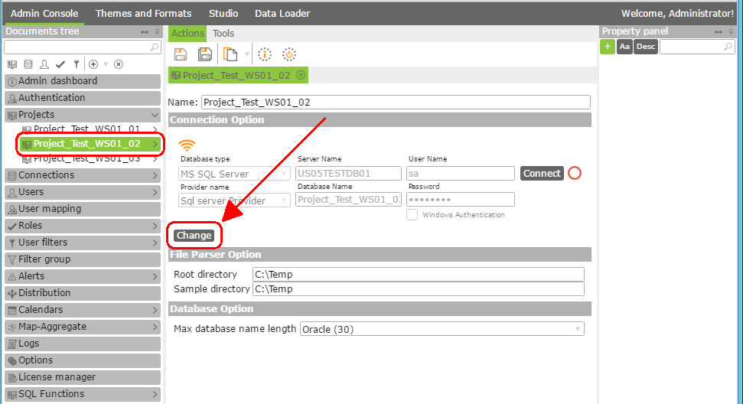  
  
After clicking “Change” you will get the following screen where you can modify the connection settings for *Meta*, *Data* and optional *Staging* DB’s for that given Project.  Be sure that “Add Existing” tab is selected; otherwise your DB’s will be re-initialized (deleted and re-created).  
  
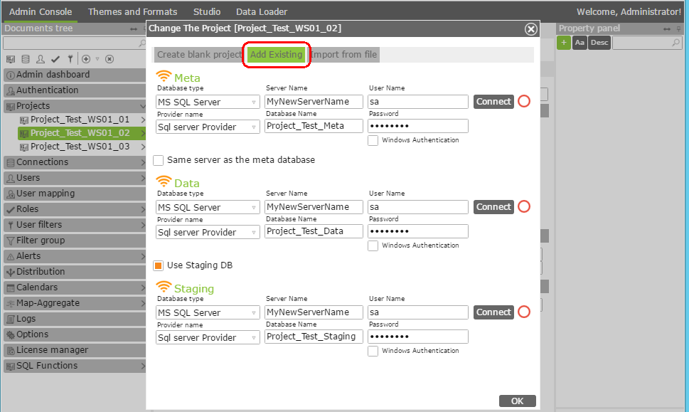

**Insight Studio** - web app  
    “Data DB” Data Source (*Data*) must be confirmed  
    “Staging DB” Data Source (*Staging*) must be confirmed  
  
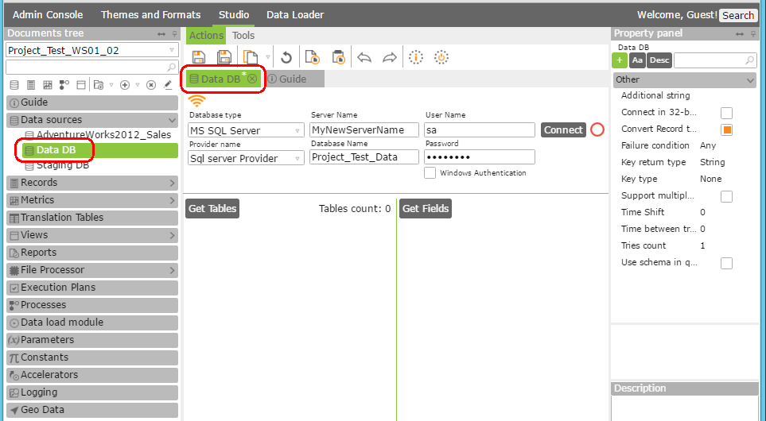  
  
  
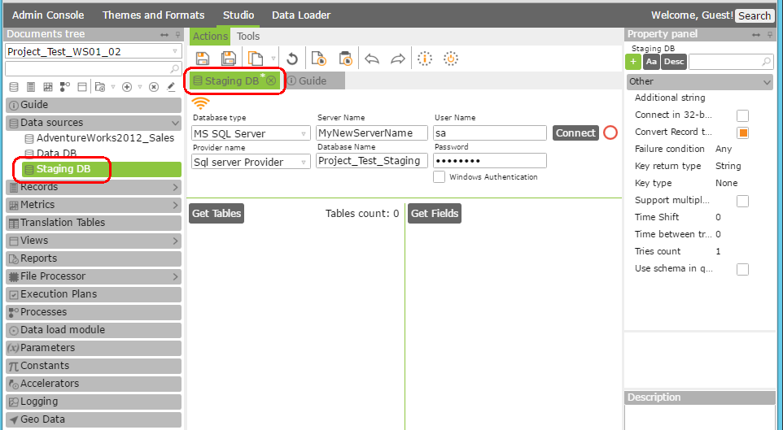

**Additional Notes**

It is strongly recommended to make sure all new DB connections are changed, tested, and everything is verified to be working correctly on the “new” DB server before disabling the “old” DB server.  If the “old” DB server is disabled first, you will not be able to log into **Insight Installation Manager** and a re-install of Insight would need to be performed (this can be done by launching the **Insight Installation Manager** from the command line with an added “/i” parameter).

**Related KB Articles**

**13452**:  Kofax Analytics for Capture - KAFC 1.2.x DB Connection Maintenance